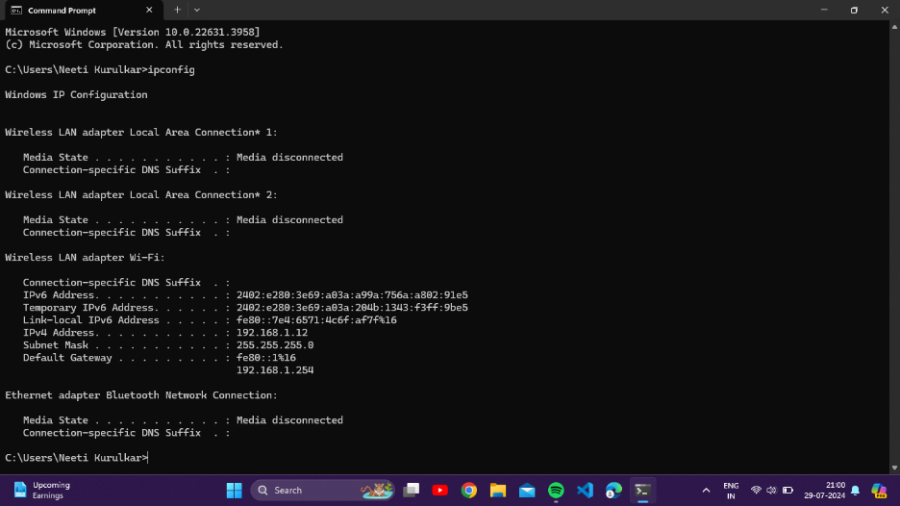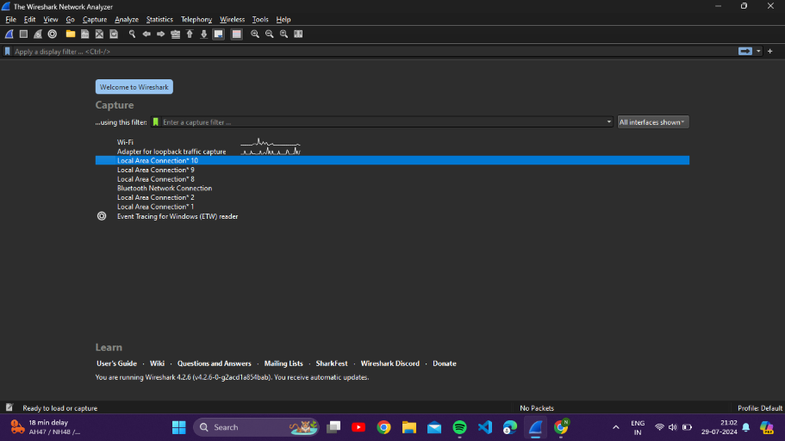
Fig 1 : Entering ‘ipconfig’ command into cmd Fig 2 : Number of networks connected to the system

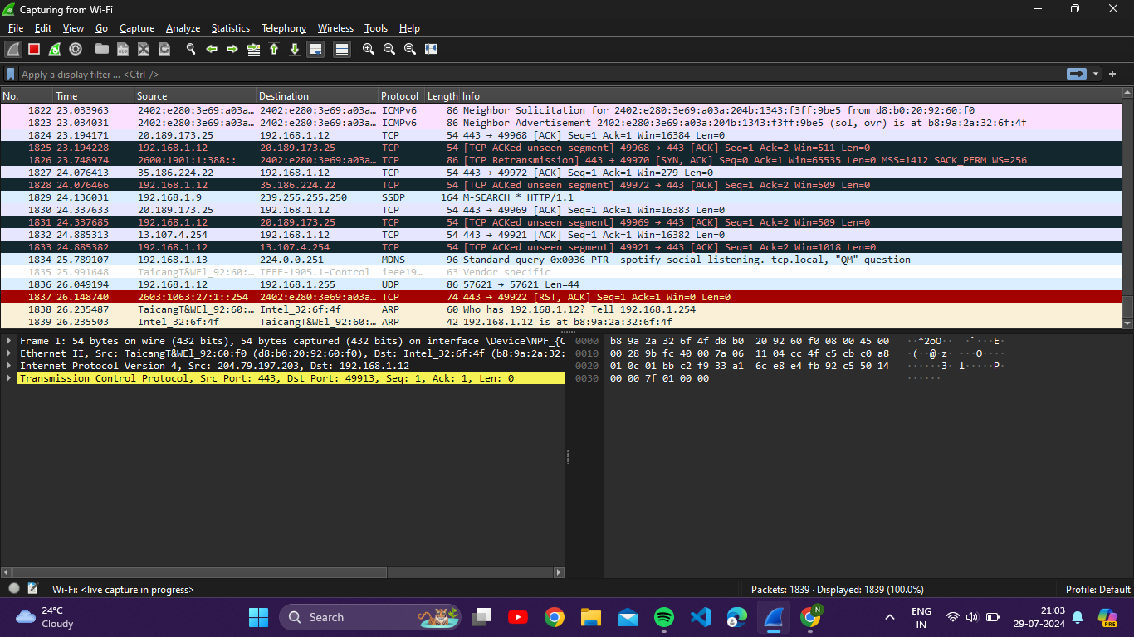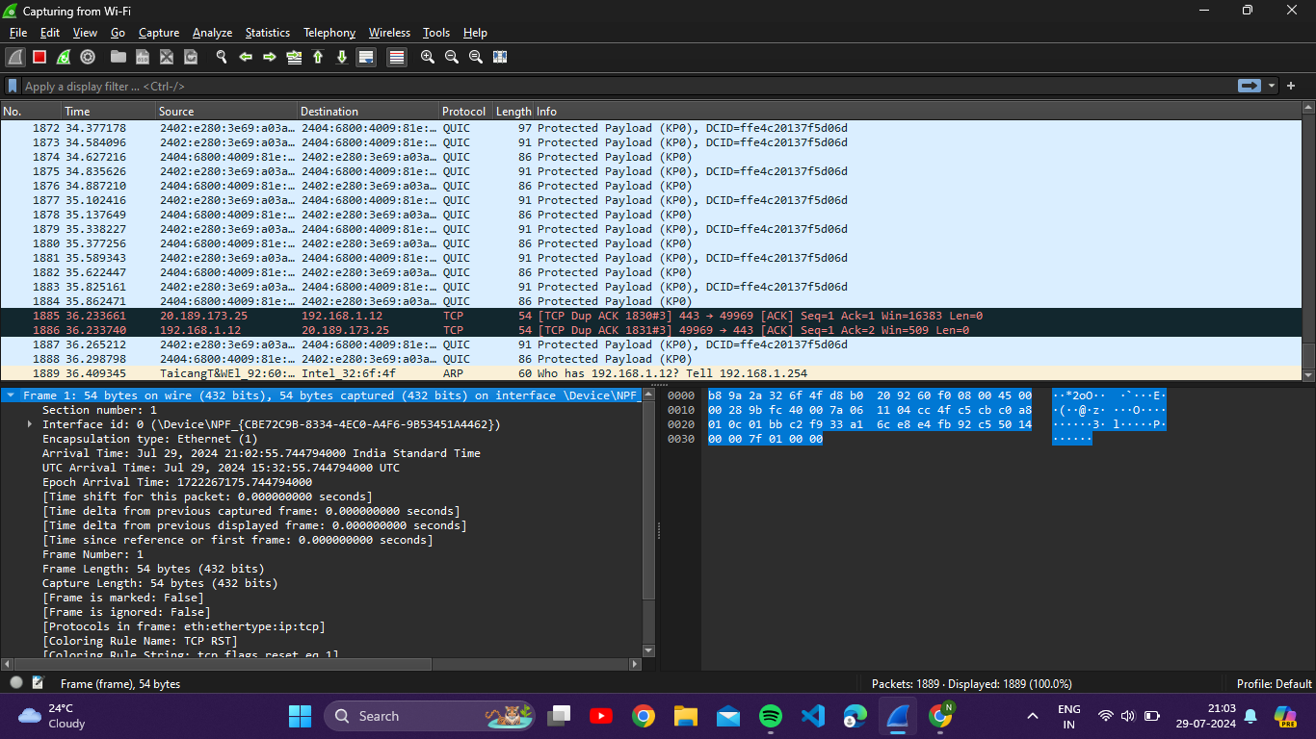
Fig 3 : Number of packets traced Fig 4 : Frame details

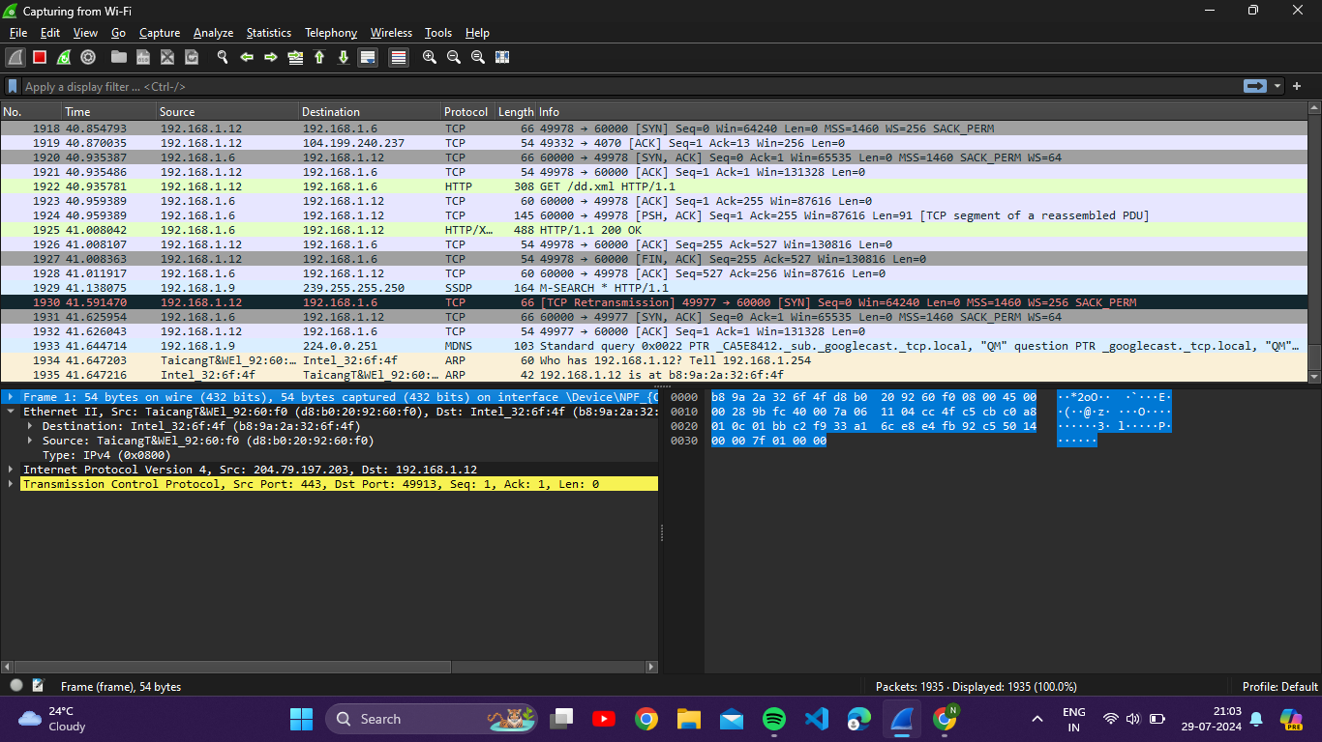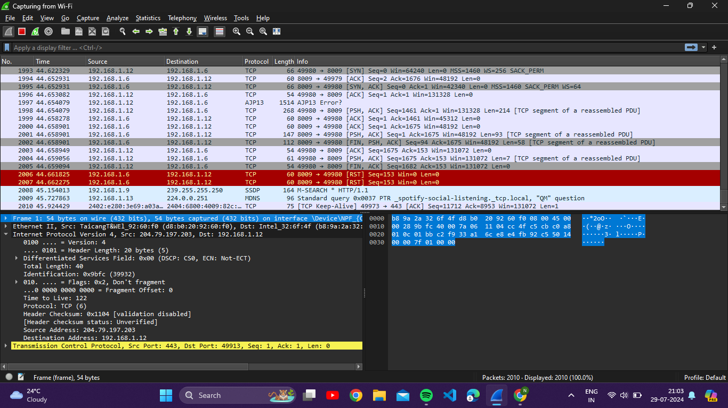
Fig 5 : Ethernet details Fig 6 : IPV4 details

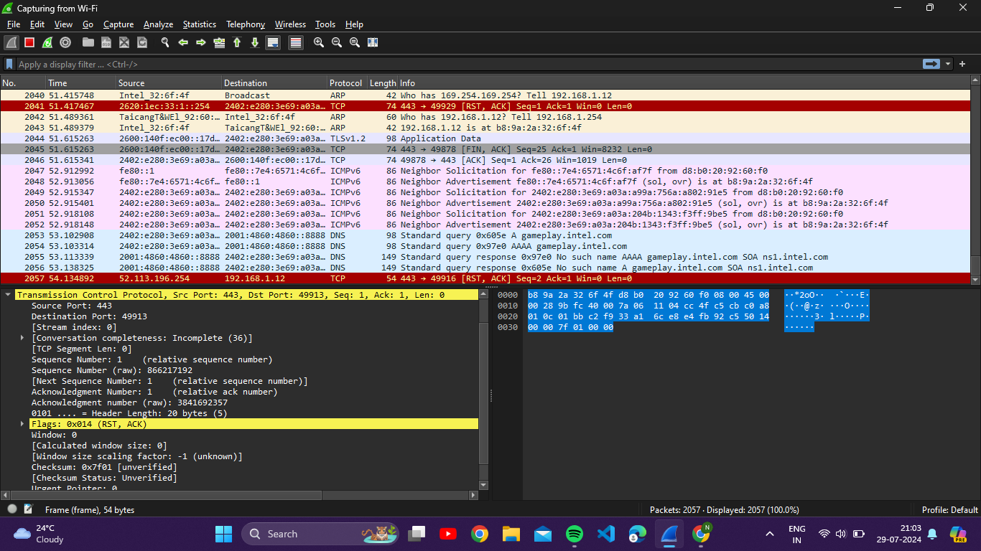
Fig 7 : TCP details

